Project name: ANTI-RAGGING PORTAL

Database Design Specification

DOCUMENT VERSION HISTORY

Document Version | Date Issued | Comments
1 | 23/07/2019

Table of Contents

Table of Contents 2
1 Introduction 3
2 Conventions followed 3
3 Abbreviations used 3
4 Entity Relationship Diagram 4
5 Tables 5

Introduction

The object/relationship pair is the cornerstone of the data model. These pairs can be represented graphically using the entity/relationship diagram. The ERD (Entity-Relationship Diagram) was originally proposed by Peter Chen. The primary purpose of the ERD is to represent entities (data objects) and their relationships with one another.
The ER Diagram of the assigned project ANTIRAGGING PORTAL has four major entities namely: Admin, College, Student. These entities have their respective attributes enlisted with them. To make the working more clear few more entities have been added in this diagram namely userId, password, firstname, lastname, Email, contact number, college, complaint section, College-Id, College-name, Address, Feedback.
The Administrator as stated manages the operations such as Update, Manages, and Receive Feedback . These operations are stated as relations and as applicable are joined to their respective entities to perform operations.
The Student have major operations of Searching for solution of their problem, making for Complaint for registering. These operations are stated as relations and as applicable are joined to their respective entities to perform operations.
The Admins has major operation of removing the solved problems and taking the feedback from the students These operations are stated as relations and as applicable are joined to their respective entities to perform operations.

Conventions followed

HUNGARIAN CONVENTION

Entity Relationship Diagram

  - ADMIN

1.1ADMIN manages STUDENT,COLLEGE .

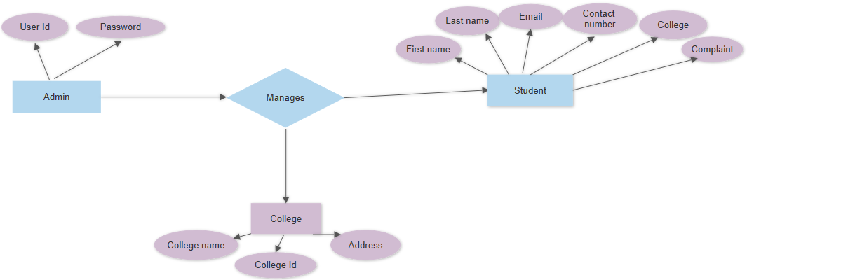
1.2 ADMIN moderates comments , Student comments , updates, feedback,

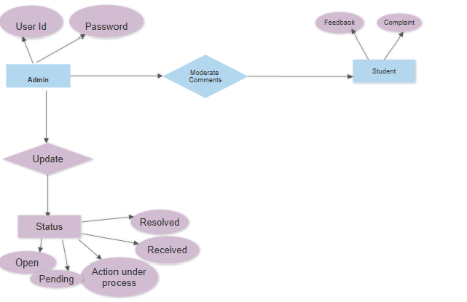

2.STUDENT

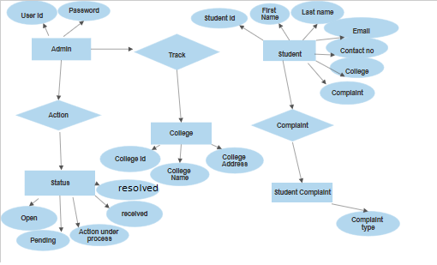

Tables

Tables are listed below –
4.1 REGISTER

Table Name | REGISTER
Description | This table basically holds the information about the student who register complain.
Field Name | Data type | Constraints | Comments
SNo | Int(11) | Primary key | Serial Number.
First Name | varchar(20) | No | First name of the student.
Last Name | varchar(20) | No | Last name of the student.
Email | varchar(50) | No | Email of the student.
Contact no. | bigInt(20) | No | Contact number of the student.
College name | varchar(40) | No | College name of the student.
Complain | Maximum text | No | Complaint of the student.
TrackID | varchar(20) | No | Track ID of the complaint.
Status | varchar(20) | No | Status of the complaint.

CONTACT:

Table Name | CONTACT
Description | This table will contain the basic information about the query made by the user.
Field Name | Data type | Constraints | Comments
SNo | Int(11) | Primary Key(auto increment) | Serial number.
Name | Varchar(50) | No | Name of the user.
Track ID | Varchar(20) | No | It is a Track ID of a user.
Email | varchar(40) | No | Email of a user.
Contact No | BigInt(20) | No | Contact number of a user
Query | Medium text | No | Query made by user to admin.
Status | Varchar(20) | No | Status of a query.

4.3 FEEDBACK:

Table Name | FEEDBACK
Description | This table holds the information about the feedback given by the students.
Field Name | Data type | Constraints | Comments
SNo | Int(11) | Primary key | Serial number.
Name | varchar(20) | No | Holds the name of the student.
Email | varchar(40) | No | Holds the Email of the student.
OE | varchar(20) | No | Holds the overall experience of the portal.
TR | varchar(20) | No | It takes the feedback about timely response of the admin.
OSupport | varchar(20) | No | It takes the feedback about overall support of the admin .
OSatisfaction | varchar(20) | No | It takes the feedback about overall satisfaction of the admin .
Rate | Int(11) | No | Rating between 1 to 5.
Comment | Medium text | No | Comments of the students.
Status | varchar(20) | No | Status of the feedback whether reviewed or not.

